Task 2 - Simulating a Collaborative Workflow in Figma:

**1. Project Creation and Sharing :**

* **New Figma file created. This screenshot shows the initial, empty canvas of a newly created Figma design file, ready my design process to begin.**

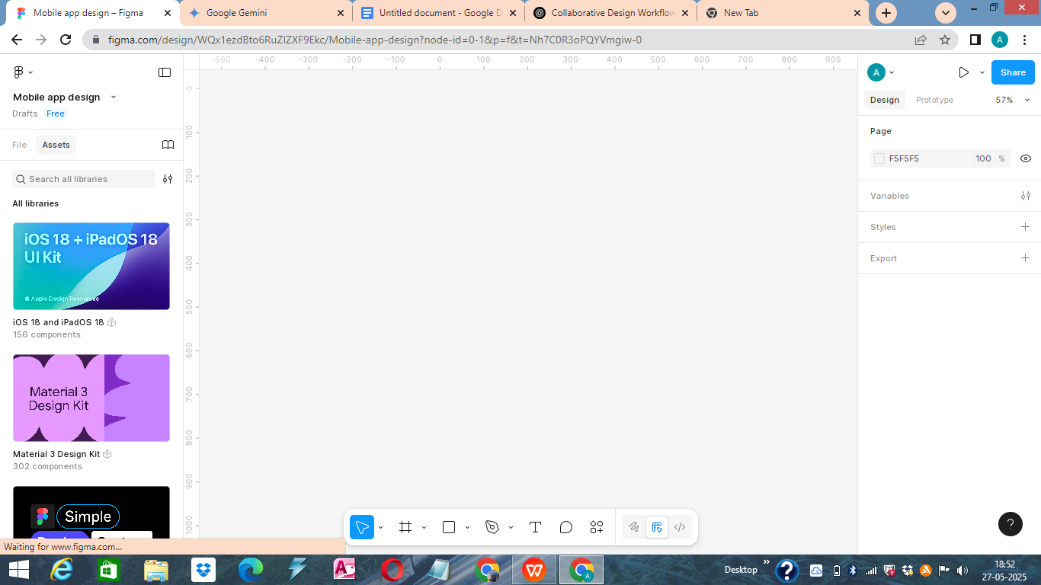

* **Initial content added to the file. Here, I've added a basic mobile frame and a placeholder element. This provides a starting point for my team members to review and build upon.**

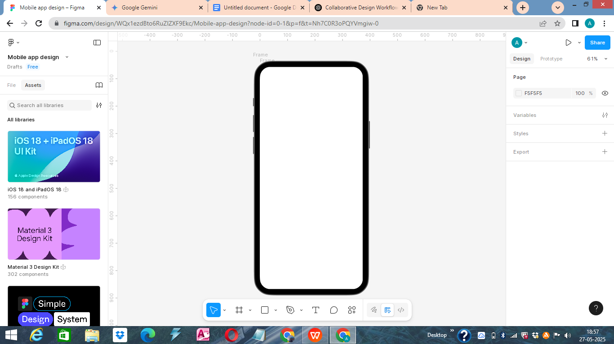

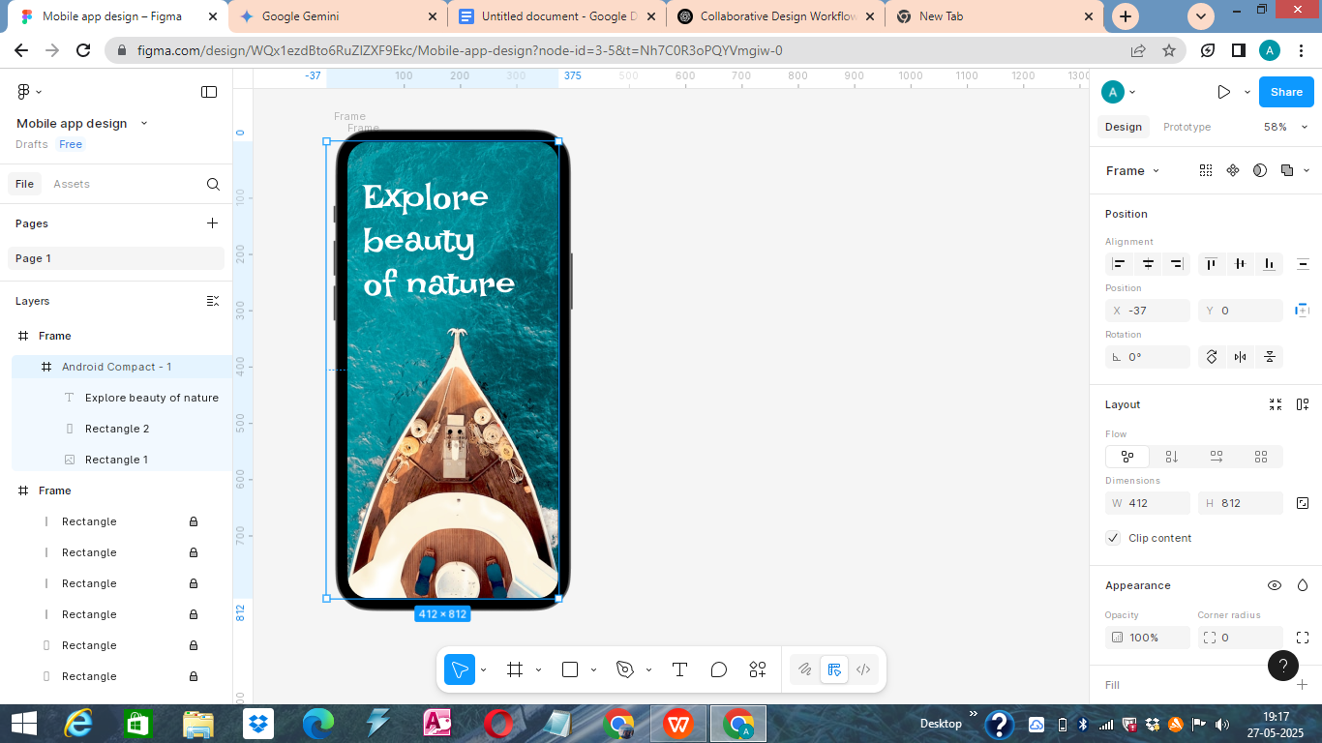

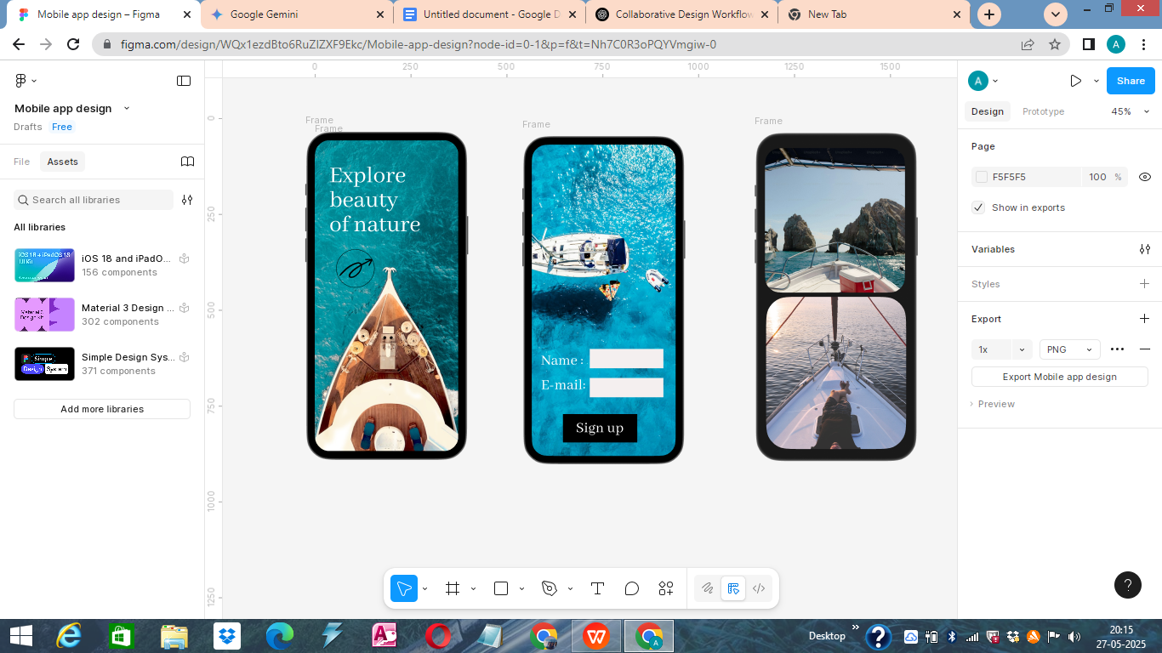

* **Share modal showing team members invited with "Can edit" permissions.This image displays the "Share" modal, where I've invited collaborators by email and granted them "Can edit" access. This enables them to directly modify the design, fostering true collaboration.**

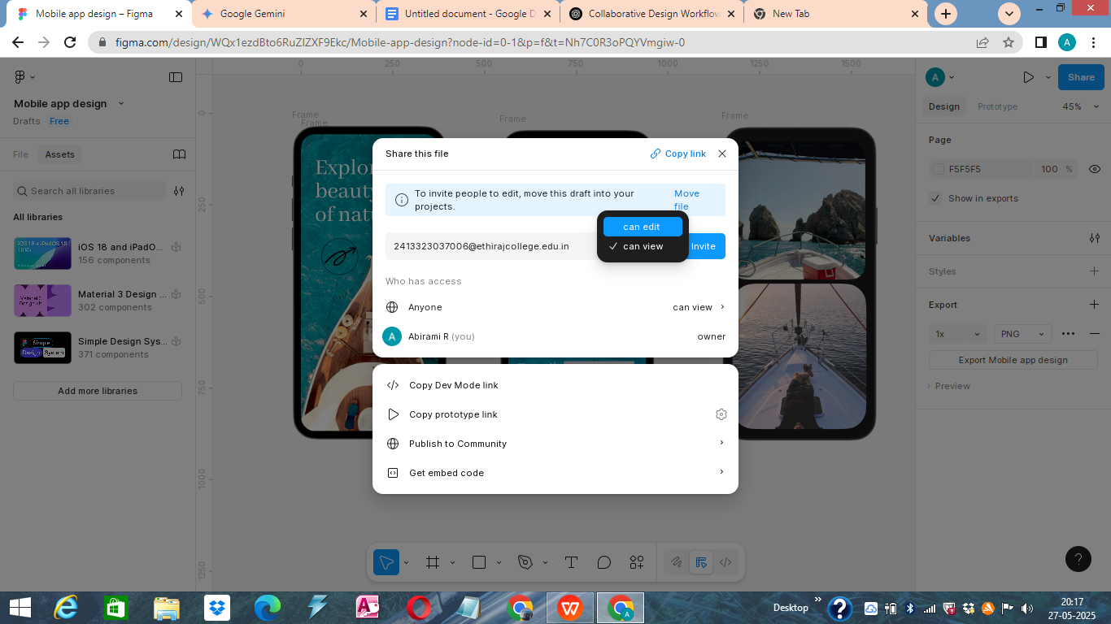

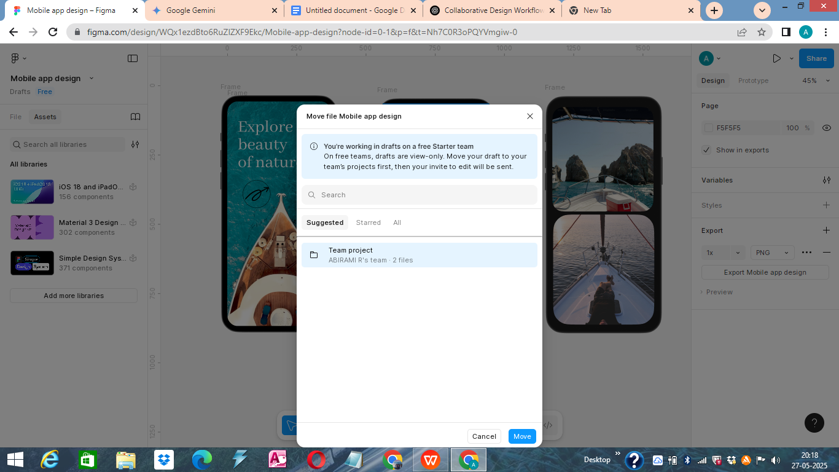

**2. Collaborative Design and Commenting :**

* **Real-time collaboration – multiple cursors/selections visible.This screenshot demonstrates Figma's real-time collaboration in action, with multiple cursors and selections visible on the canvas. Each cursor represents a different team member actively working on the file simultaneously.**

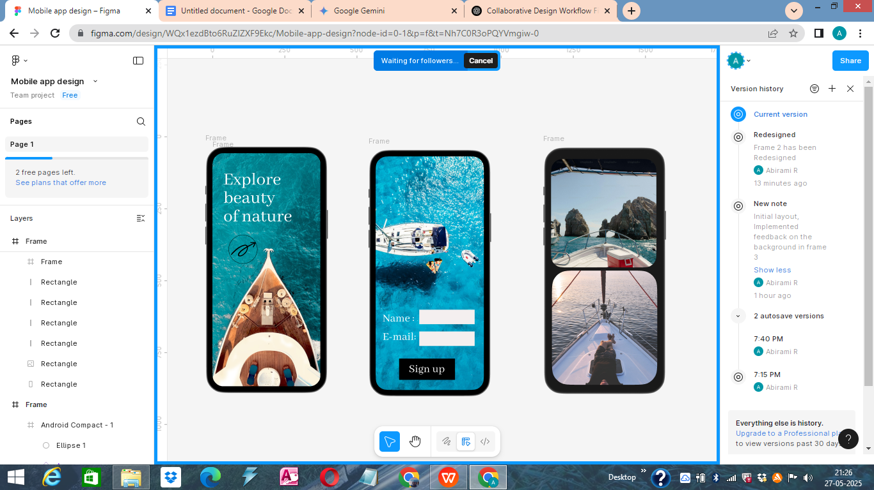

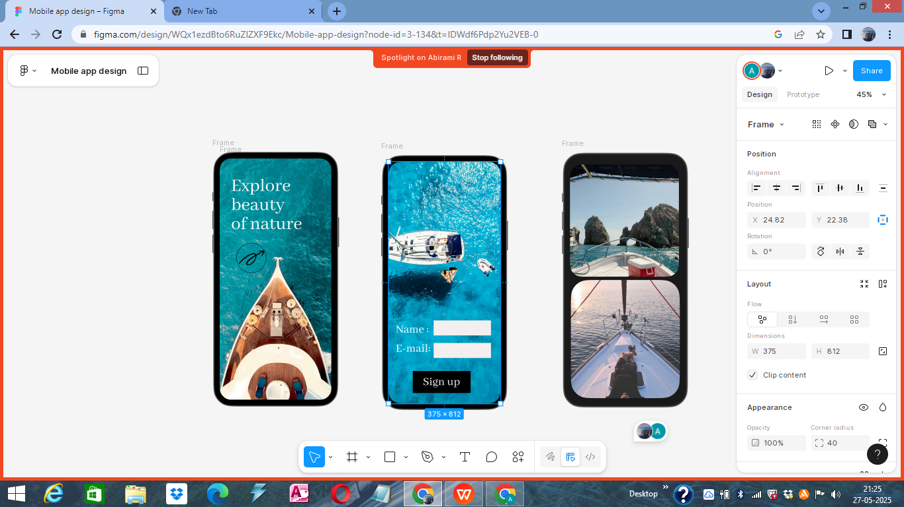

* **Comment thread on the design canvas.This image captures a comment thread directly on the design. Comments facilitate contextual feedback and discussion, allowing team members to highlight specific areas and share their thoughts.**

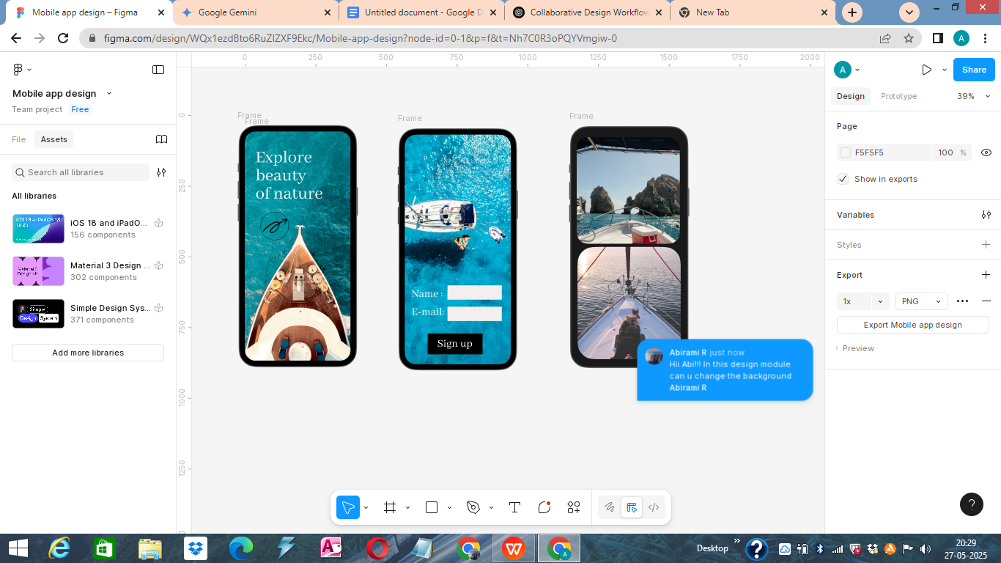

* **Resolved comment. This screenshot shows a comment that has been marked as "resolved." This indicates that the feedback has been addressed or the discussion concluded, helping to keep the feedback loop clean and organized.**

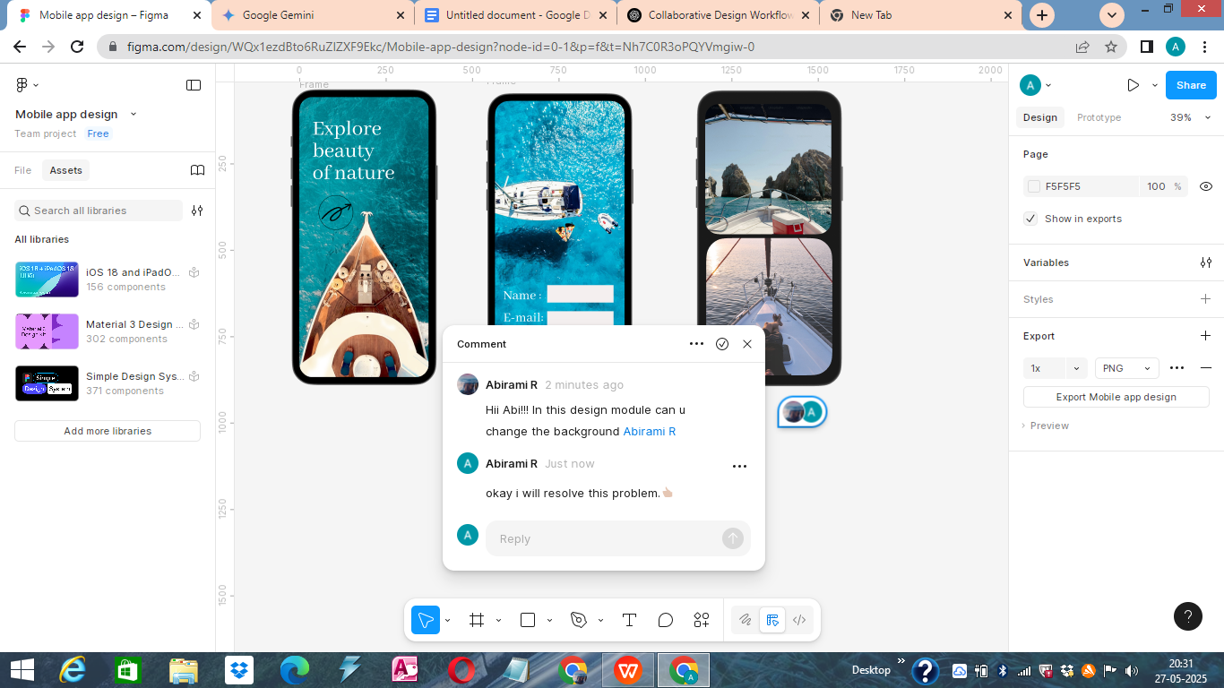

**3. Version Control :**

* **Saving a new version to history.This image shows the "Save to Version History" dialog. Manually saving versions with descriptive names that allows me to mark significant milestones and maintain a clear audit trail of design progress.**

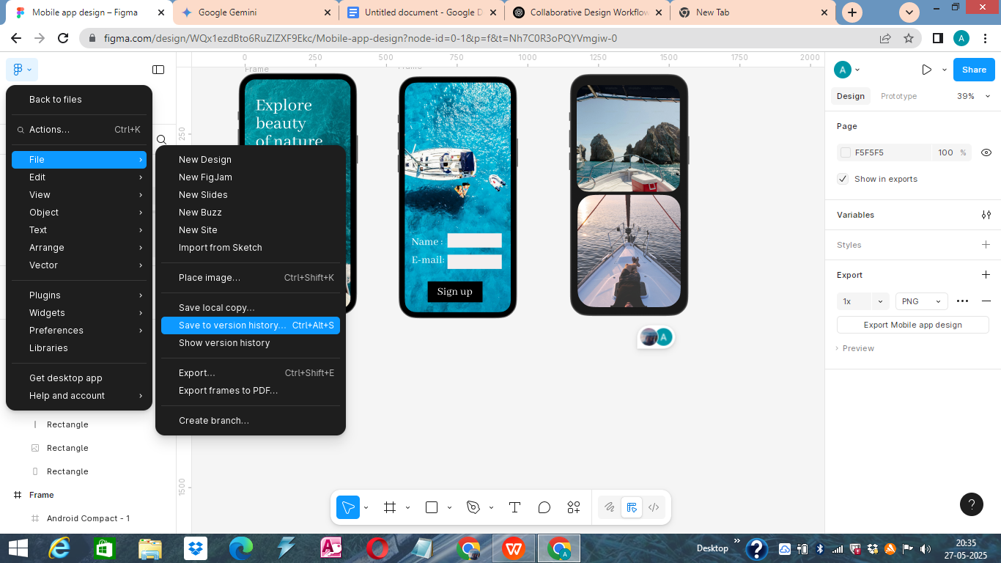

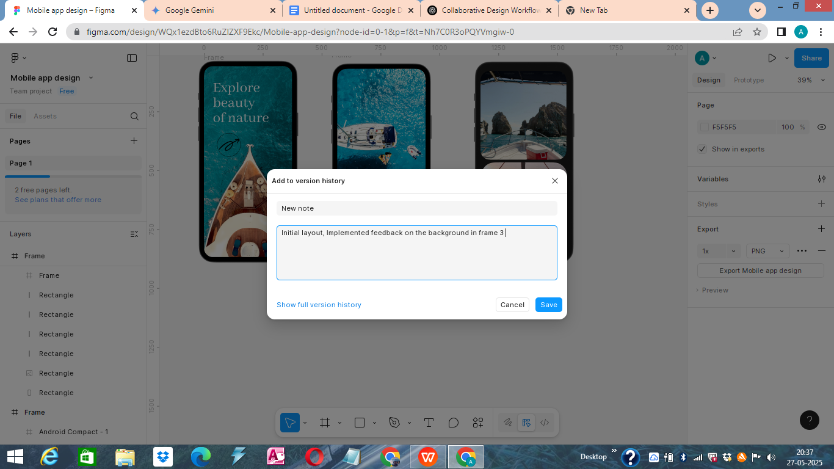

* **Version History panel showing multiple versions.Here, I see the Version History panel, displaying a list of all saved versions (both manual and automatic). This panel provides a comprehensive timeline of design changes, making it easy to track evolution.**

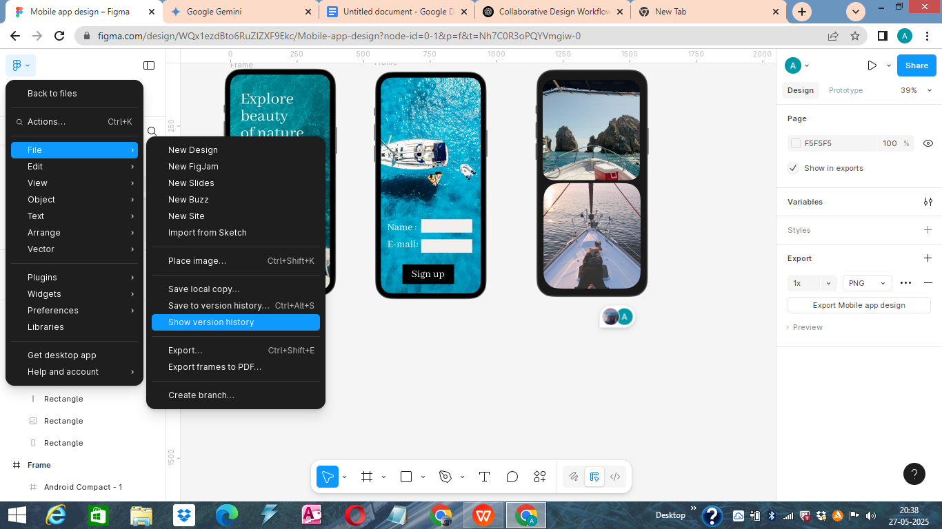

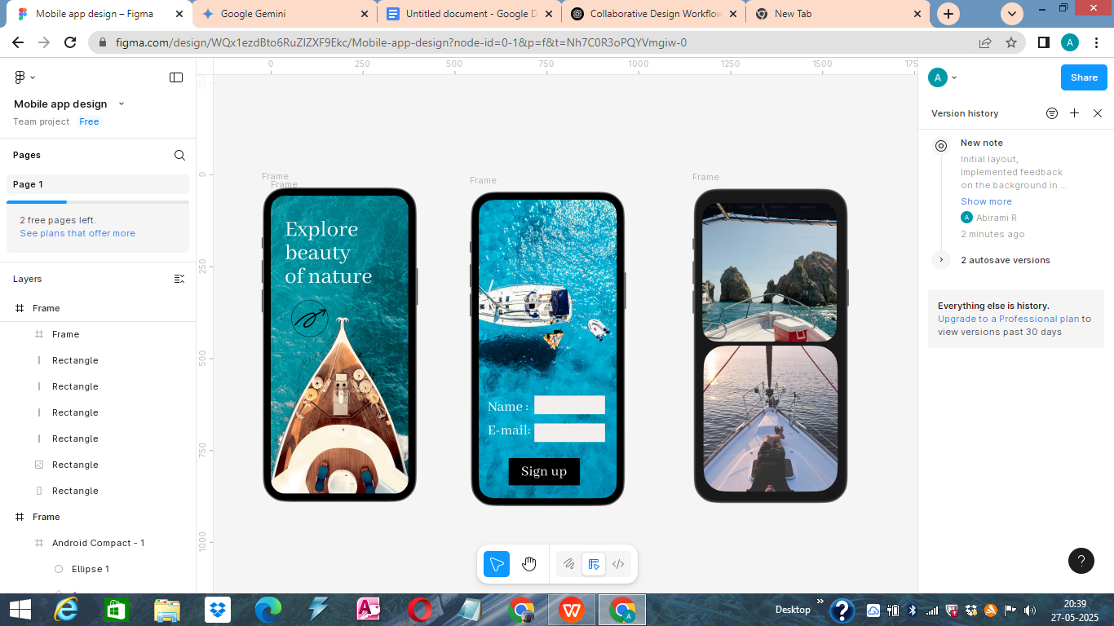

* **Design reverted to an earlier state after restoring a version. This screenshot demonstrates the ability to "restore" a previous version from history. This crucial feature allows me to roll back to an earlier design state, providing a safety net for iterative design and experimentation.**

